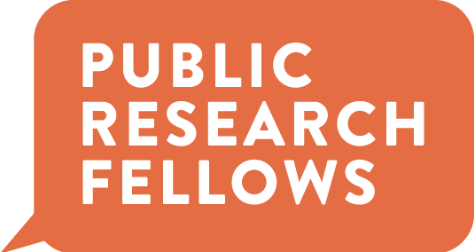

Public Research Fellows 2021-22
Call for Student Applicants

The Public Research Fellows is a new program on campus that brings students and faculty together from across disciplines to explore timely topics and problems through publicly-engaged research projects. In 21-22, the program will adopt a new Working Group model in which faculty fellows partner with students to develop projects around topics of their own design. If you’re interested in an undergraduate research experience that connects scholarship to the wider public and the communities in which we live, check out the program details and Working Group descriptions below and apply to be a Student Fellow.

What do Student Fellows do?

- Take a 1-credit reading course in both Fall and Spring semesters (in person; Fall meeting time: W 7:10-8:05pm); the course will provide background and tools in public humanities methods with the goal of helping engage research teams’ projects with a wider community

- Participate in regular meetings with your faculty partners (at least once every two weeks); help develop Working Group projects; conduct research under faculty guidance

- Help plan and participate in program events, such as a Spring Symposium (date TBD)

What’s in it for Student Fellows?

- 3 credits total (1 credit of CAS 391 in both Fall and Spring and 1 credit of Undergraduate Research in the Spring)

- Experience in undergraduate research and working closely with faculty

- The chance to work with a close-knit, dedicated group of students from a variety of disciplines

- The opportunity to help shape a new and exciting program on campus

What do previous Student Fellows say about their experience in the program?

Click on the links below to watch short clips of Student Fellows discussing their takeaways, such as:

- Athena Hills on what made her work in PRF different from her other academic work
- Grace Fortson on the value of connecting research to the “real world”
- Sarah James on how the program created lasting connections for her
- The PRF interns’ short film showcasing last year’s program work

To apply:

Review the projects below, choose one to apply to, and send a resumé and cover letter to the Working Group contact by Friday, 7/30.
*Note that you may only apply to one Working Group.

********

Working Group: Table Talk: Stories of our Dinner

Faculty Members:
Cheri Buck-Perry, English
Heather Carpenter, Environmental Science

Project Description:
We aim to tell stories about the people and the northwest land and waters that feed us. Why? This past year served up extraordinary challenges and it’s clear that our local and national food culture is at a critical juncture. Although Portland prides itself on fantastic farmers’ markets, food carts, innovative chefs, a vibrant coffee culture, craft breweries, and much more, this past year’s pandemic related disruptions and the effects of climate change have taken a toll. Many are stepping up to meet the challenges and we’d like to tell the stories of some of those folks that are finding inventive new (and old) ways of feeding, working, and living. By sharing the compelling narratives of those individuals whose labor and creativity puts food on our tables and nourishes the hungry, we hope to cultivate a stronger, more resilient food culture.

We’re seeking two (or more) students to join us creating (writing, designing, and producing) a variety of possible pieces—a series of profiles, a graphic poster exhibit, a podcast, or short documentary videos. We envision collaborating with students to determine individual and joint interests to guide our choice of project outcomes. We’ll need students that are passionate about meeting and talking with people, of course, and those that have a keen interest in writing and storytelling in various forms. We’re seeking self-motivated students that are looking to develop their communication skills (and add to a portfolio of work to show future employers). Finally, we’re looking for adventurous eaters highly interested in food/food studies.

Contact:
Cheri Buck-Perry, English
buckperr@up.edu

********

Working Group: Loosen UP

Faculty Members:
Rebekah Hanson, PFA
Corey Pressman, Nursing
Susan McDaniel, PFA
Karen Eifler, Garaventa Center and School of Education

Project Description:
The goal of Loosen UP is to create opportunities for our community to slow down and restore their minds, spirits, and bodies in our fast-paced world, via a series of 1-hour sessions that blend music, poetry and visual art. Because of the fast pace of our lives, we know there will be a sense of overwhelm for many once we are back in person. We will offer gatherings for students, faculty, and staff, 2-3 times each semester, and provide opportunities to the wider neighborhood community, off-campus. Student partners will help develop these sessions, create/implement outreach strategies, and gather pre-post data on sessions’ impacts in lowering stress, cultivating a sense of hope and wonder, and contributing to healing brokenness.

Desired qualifications:
- interest in holistic approached to healing and wellness
- ability to work collaboratively
- willingness to exercise creativity and artistic imagination and curate artistic expressions for use in LoosenUP sessions
- ability to acquire and deploy data-collection skills

Contact:
Rebekah Hanson, Performing & Fine Arts
hansonr@up.edu

